**PROJECT- 1**

**Creation Of Micro Services**

**JAVA, Git, GitHub, Maven, IntelliJ Idea, Rest API**

**Step 1: - Login Spring Boot Initializer to create project structure**

**# Login Spring Boot Initializer**

**# Select JAVA language**

**# Select project in Maven**

**# Select spring boot version 3.3.7**

**# Entered Artifact and Name details in project metadata**

**# Select Packaging type and java version**

**# Select dependencies Spring Boot Web / Spring Boot Actuator( For application health check)**

**# Click on GENERATE**

**# Unzip / Extract BookingMS zip file and move this file from download to C Drive/DevopsProject**

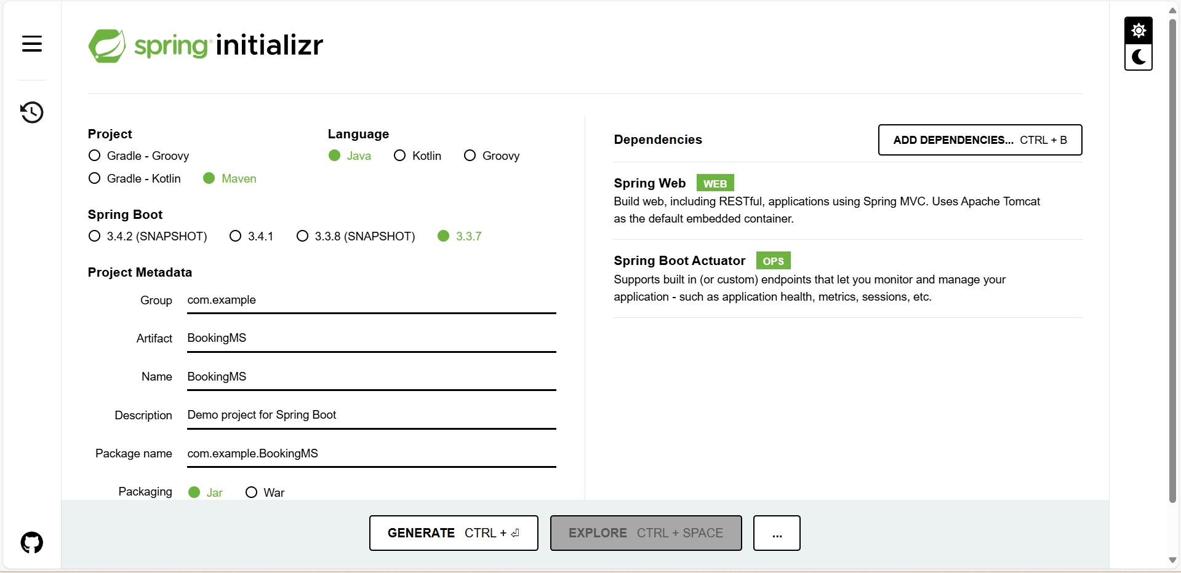

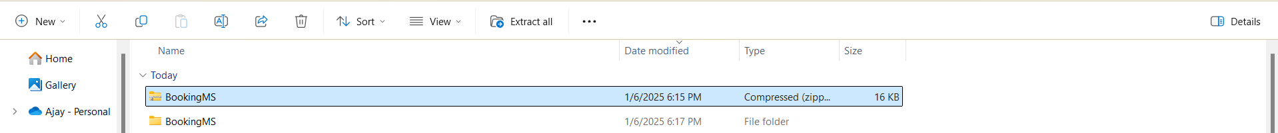

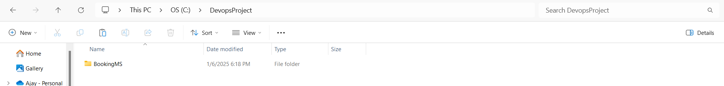

**Step 2: - Login In IntelliJ Idea and create new project using newly downloaded BookingMS project structure**

**# Open IntelliJ Idea**

**# Click on open and select BookingMS project from the C-Drive/ DevopsProject**

**# Click on Trusts Project and procced further**

**# To check BookingMS application click on main/java/**

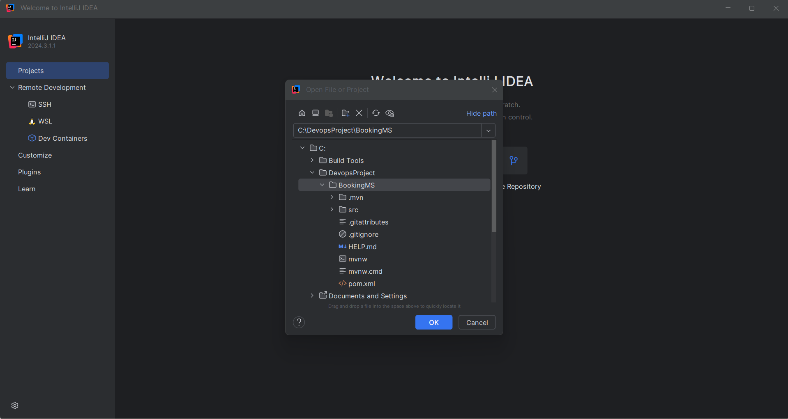

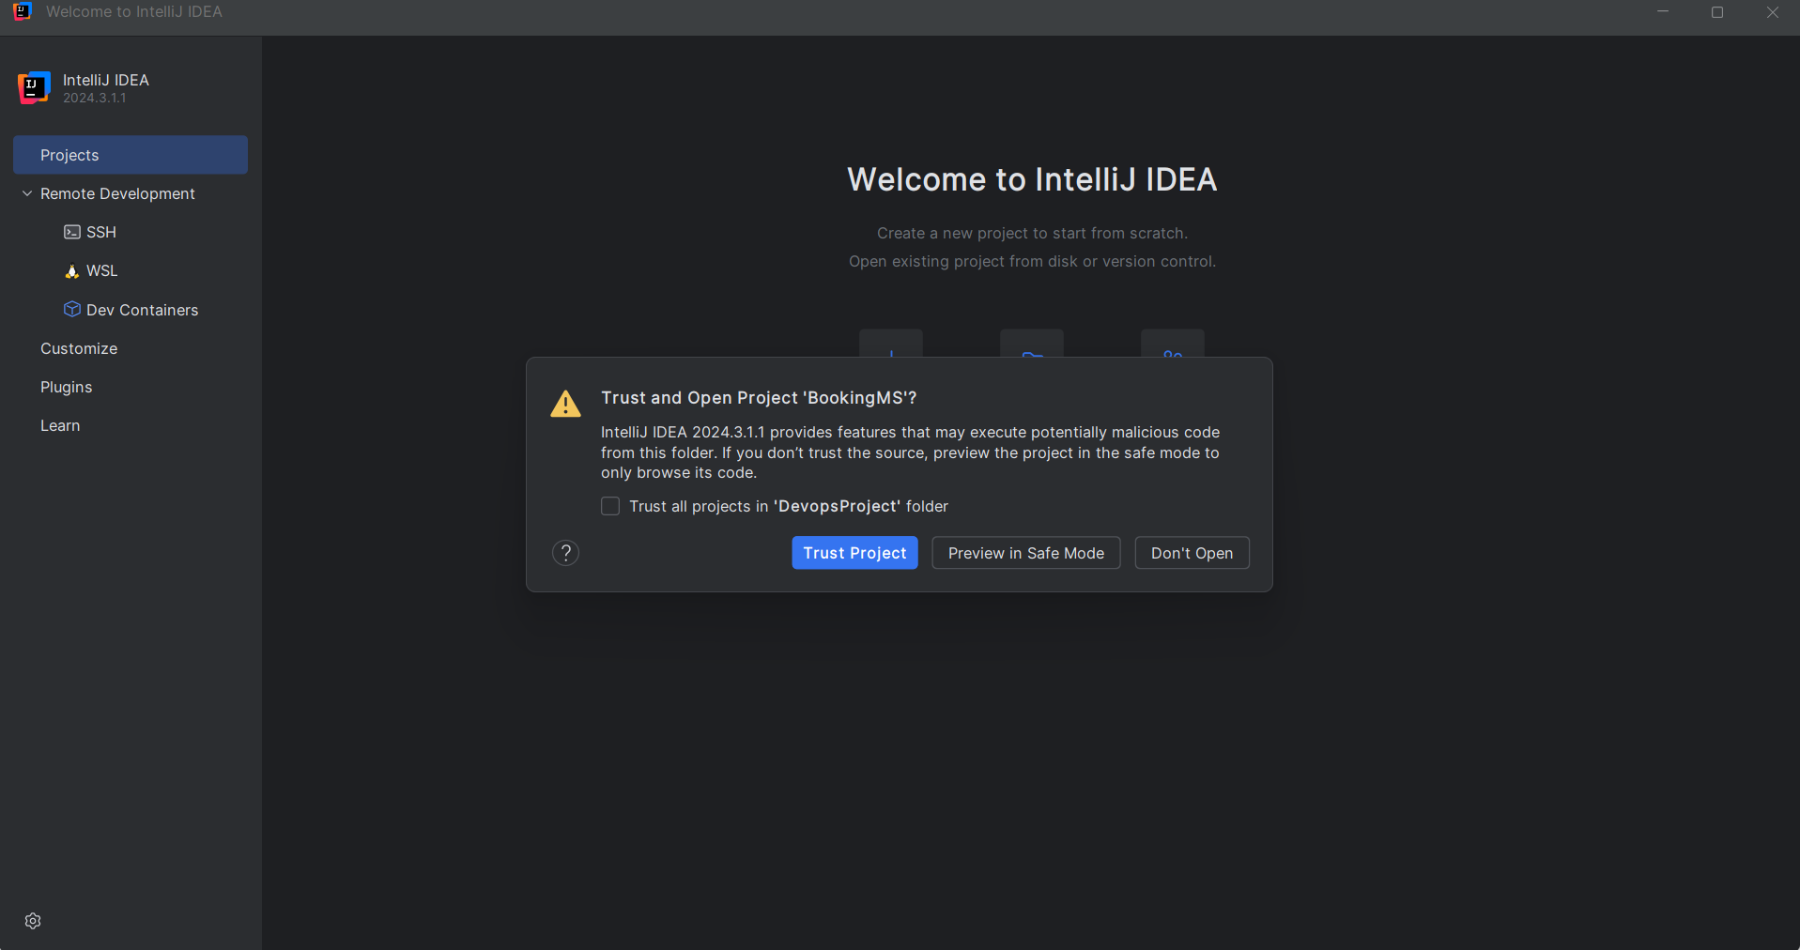

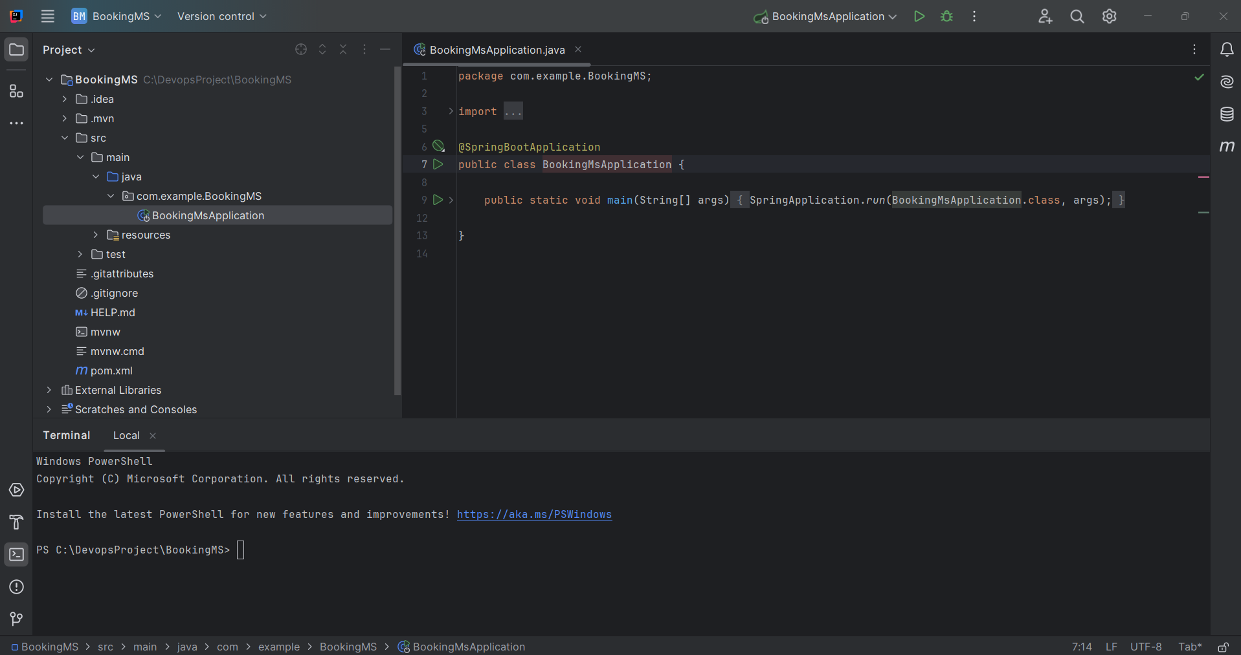

**Step 3: - Creation of GitHub repository for BookingMS project. (To upload code)**

**# Click on new for repository creation**

**# Entered Repository Name (BookingMS)**

**# Select Public option clicking on check box and make repository as public**

**# Select java in the Add.gitignore template**

**# Click on create repository**

**# Make newly created repo as master / open repo setting and edit default main as master**

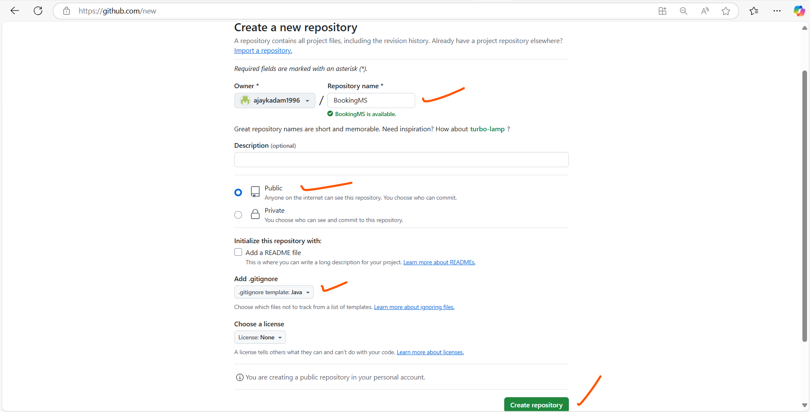

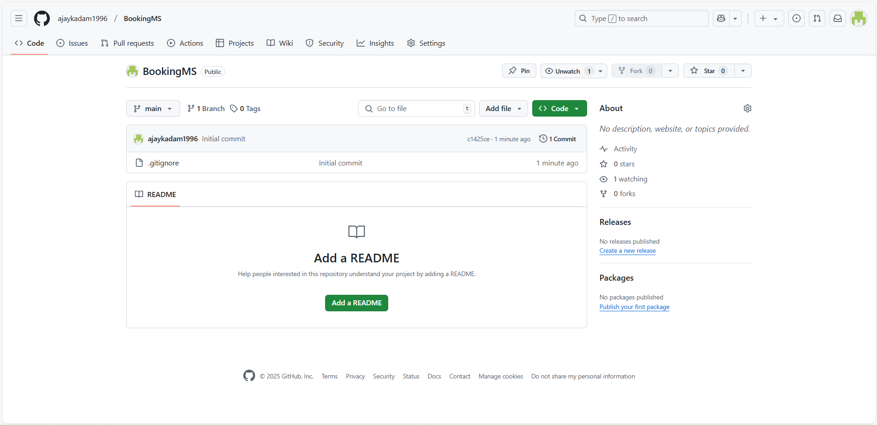

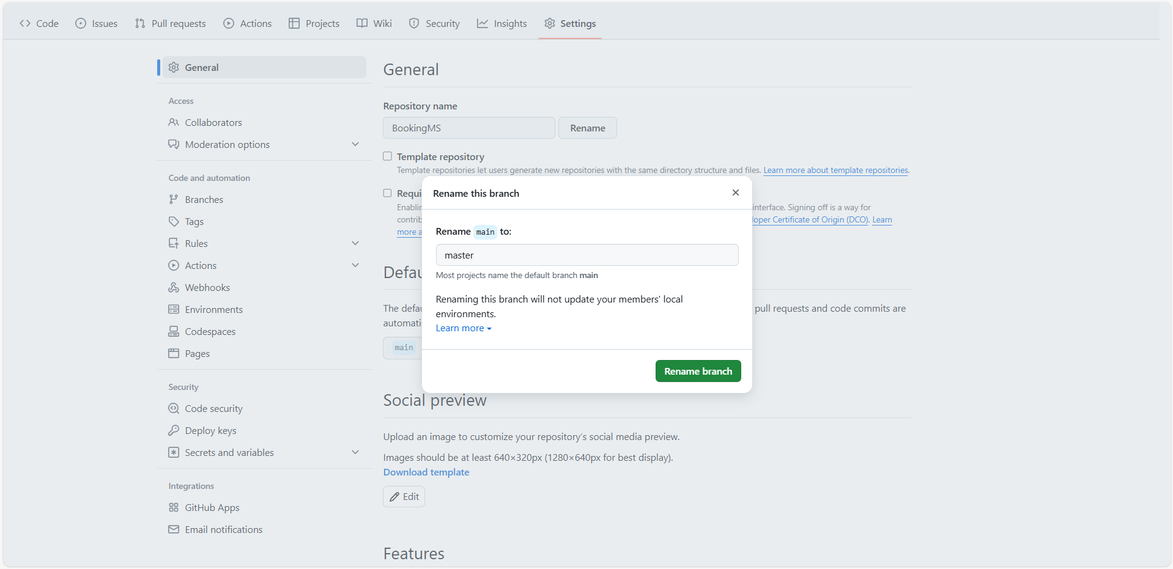

**Step 4: - Enabling version controller Git and addling newly created GitHub repo for a remote.**

**# Click on VCS option in the main navigation menu of IntelliJ Idea**

**# Click on Enable Version control Integration and select Git**

**# Open the newly created repository on GitHub and copy the URL from Code for enabling the manage remotes**

**# After enabling the version control from the VCS, Git version control is available in main navigation menu of IntelliJ Idea**

**# Select Git and click on manage remote option and add the Git repository URL in the same**

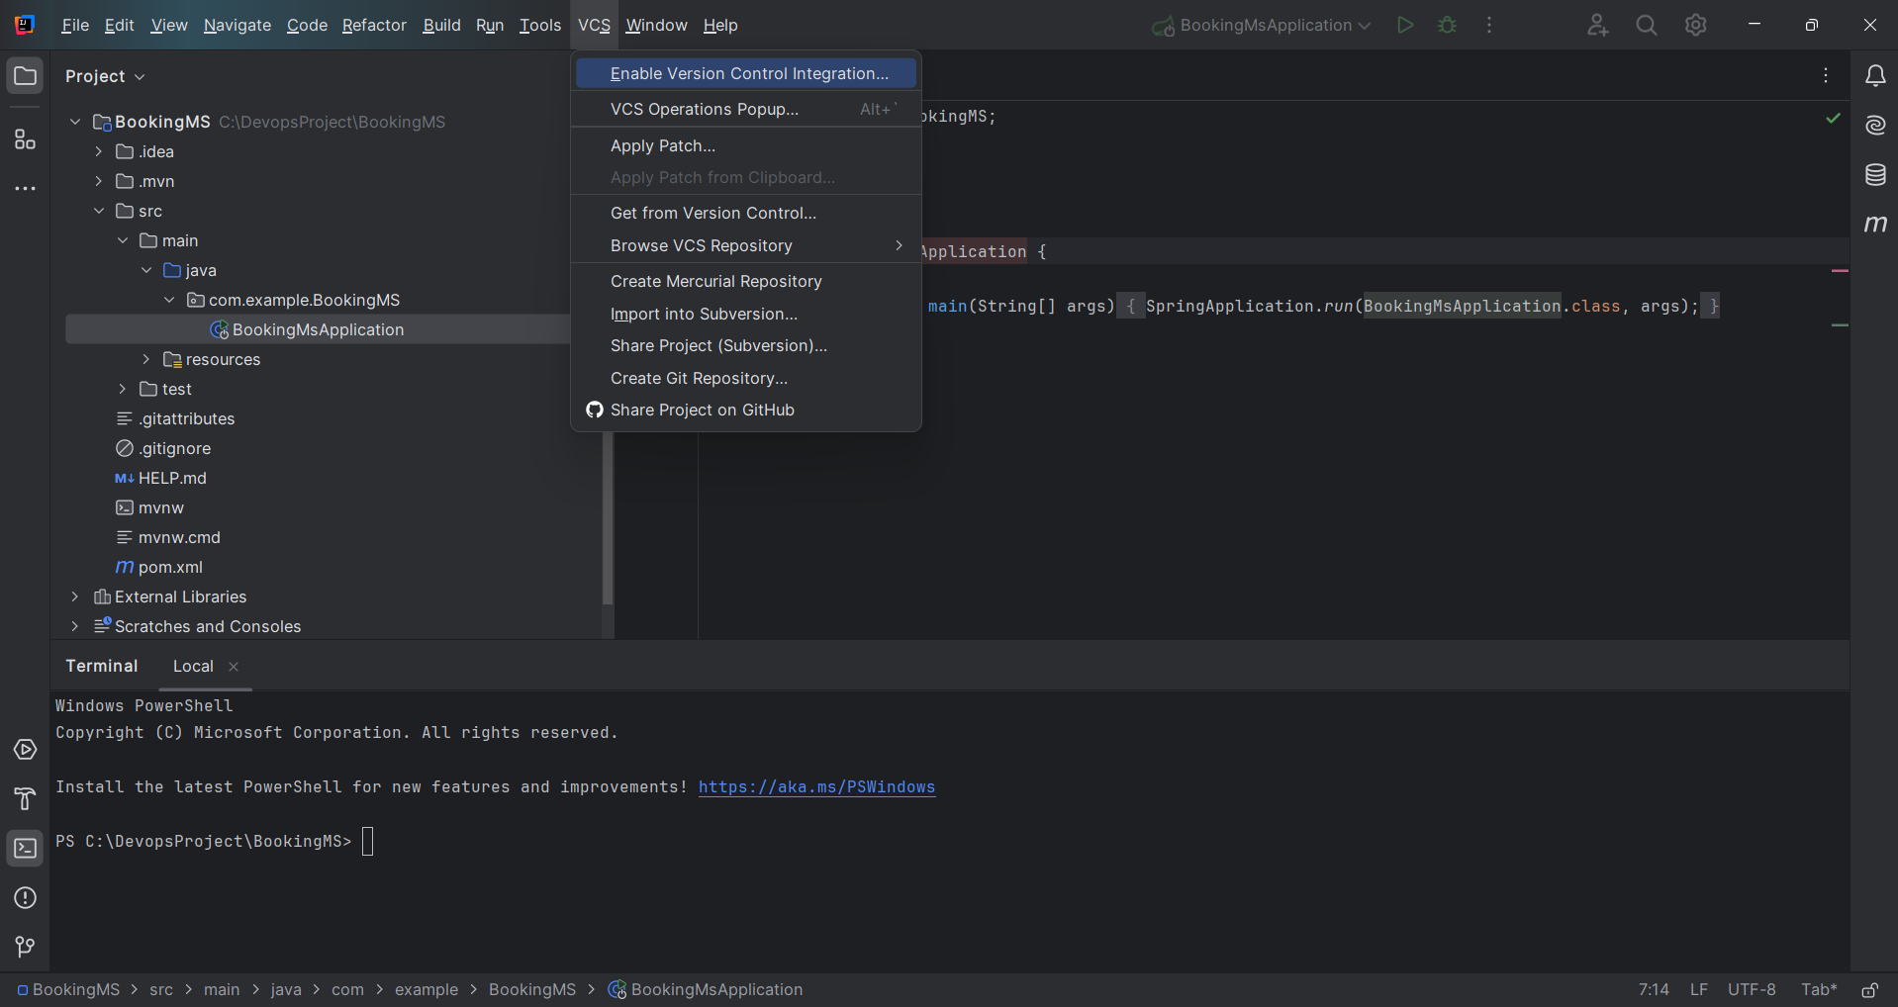

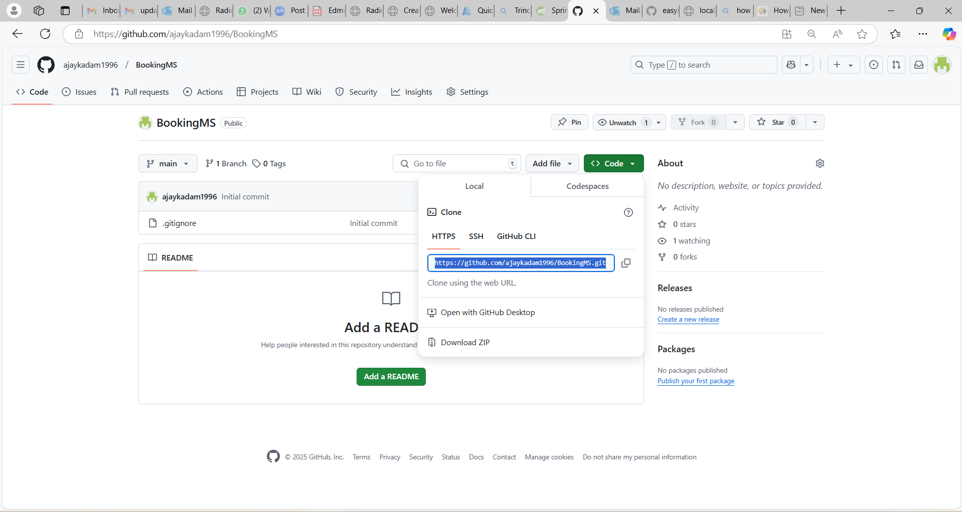

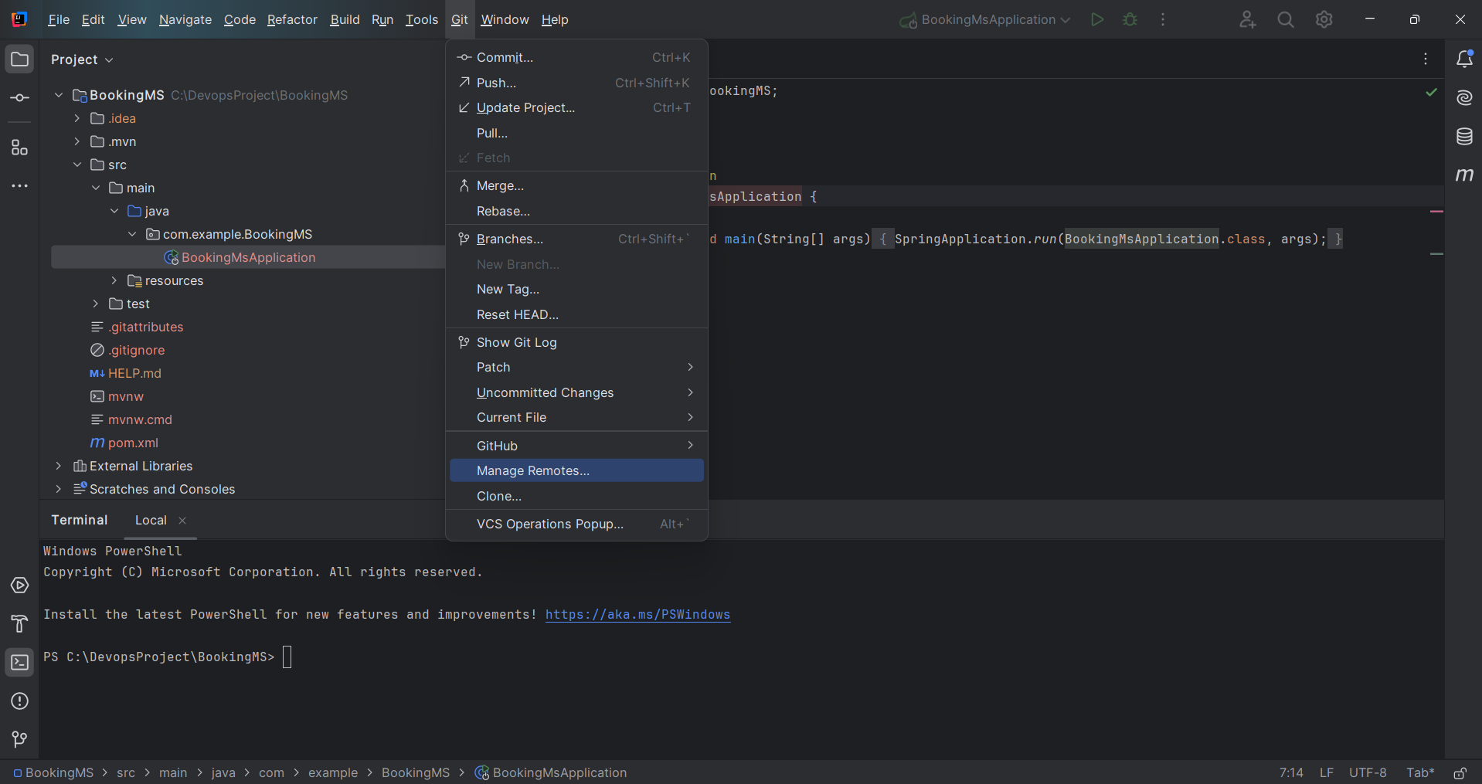

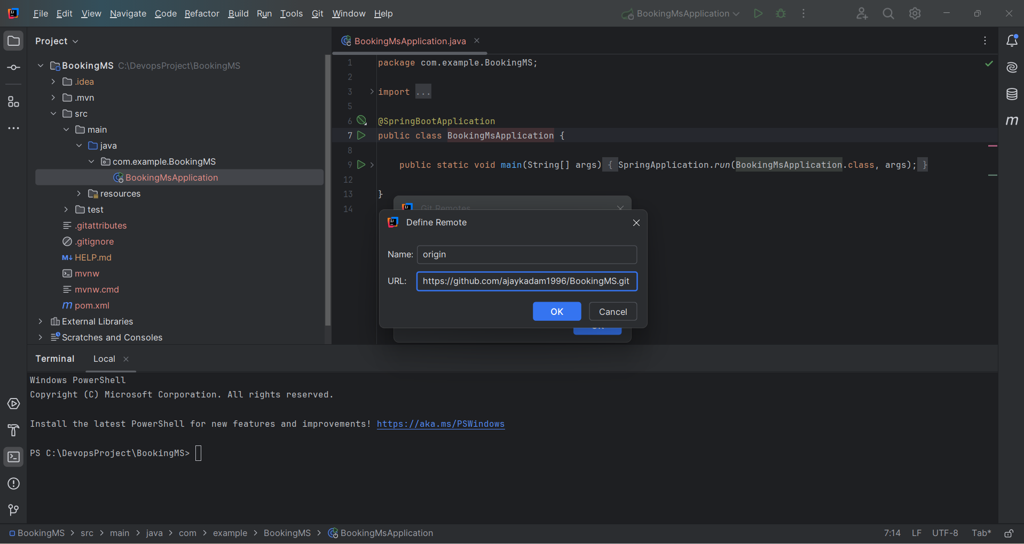

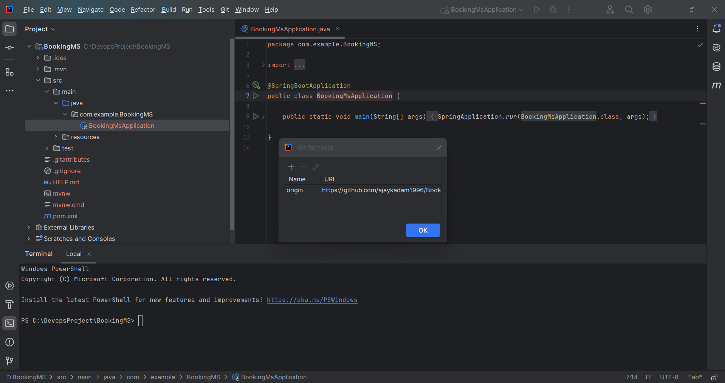

**Step 5: - Pushing code from local to GitHub remote repo using Git commands. (For the first time push)**

**1). Pull operation for remote repo (master)**

**# git pull origin master**

**# git add –all**

**# git commit -m “codeRefactor”**

**2). Push operation for code from local to remote repo(master)**

**# git push origin master -f**

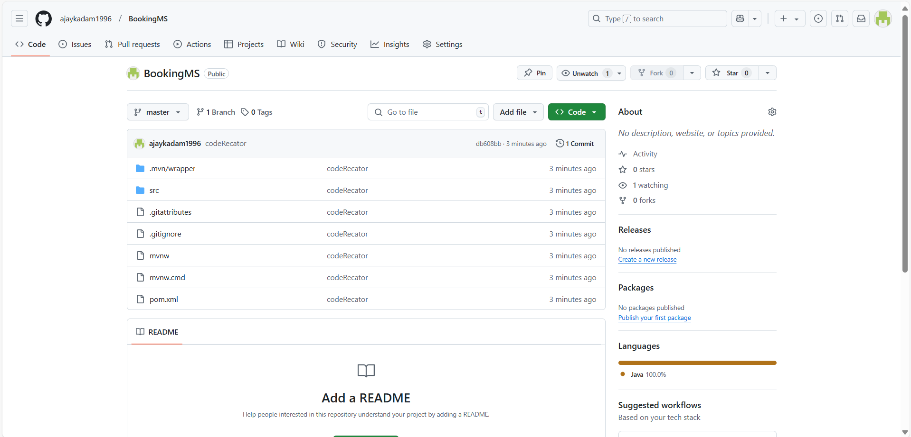

**Step 6: - Addition of new code (java class) in the existing code – java class 🡪 hotel**

**# Sample code**

**package easymytrip.example.easymytrip;**

**import org.springframework.web.bind.annotation.GetMapping;**

**import org.springframework.web.bind.annotation.RestController;**

**@RestController**

**public class hotel {**

**@GetMapping("/hotel")**

**public String getData() {return "Please book your hotel ticket for shimla t 35% discount" ; }**

**}**

**#Ringh click on main application and add new java class call hotel.**

**# Copy the above sample code in the newly added java class**

**# Entered Git status and check changes.**

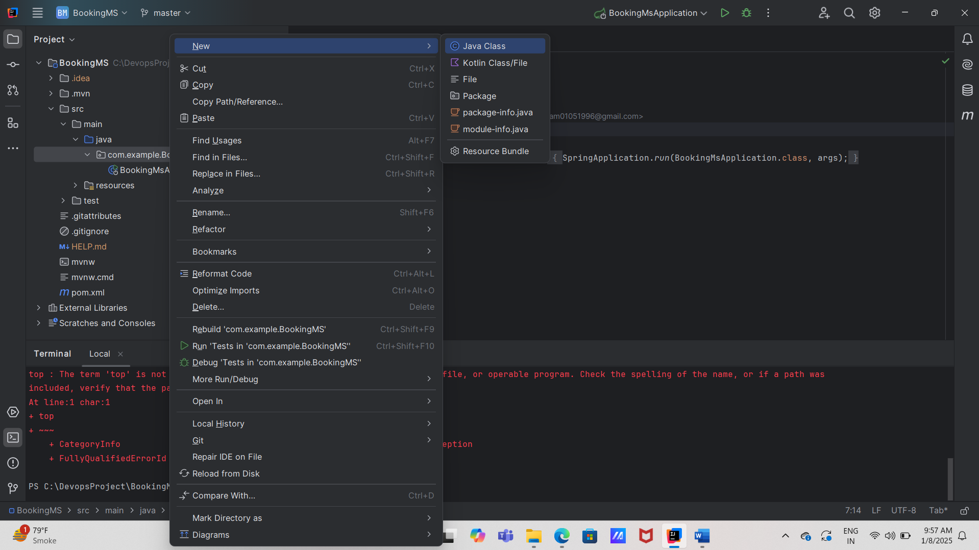

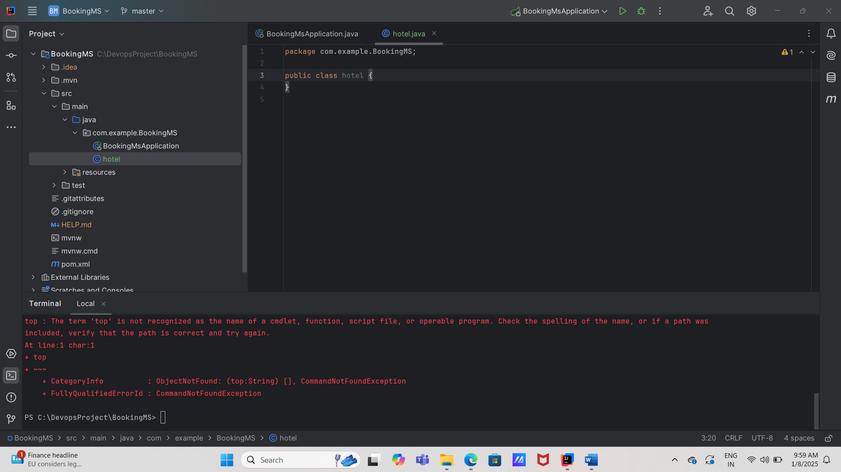

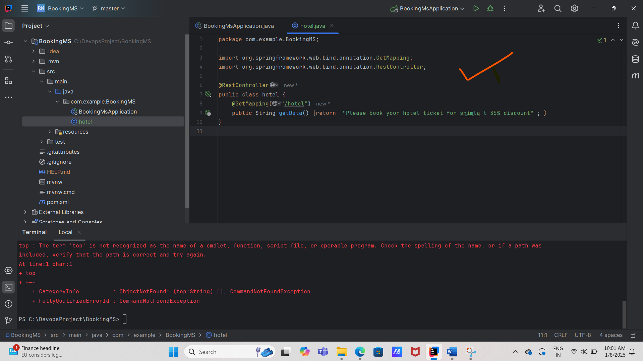

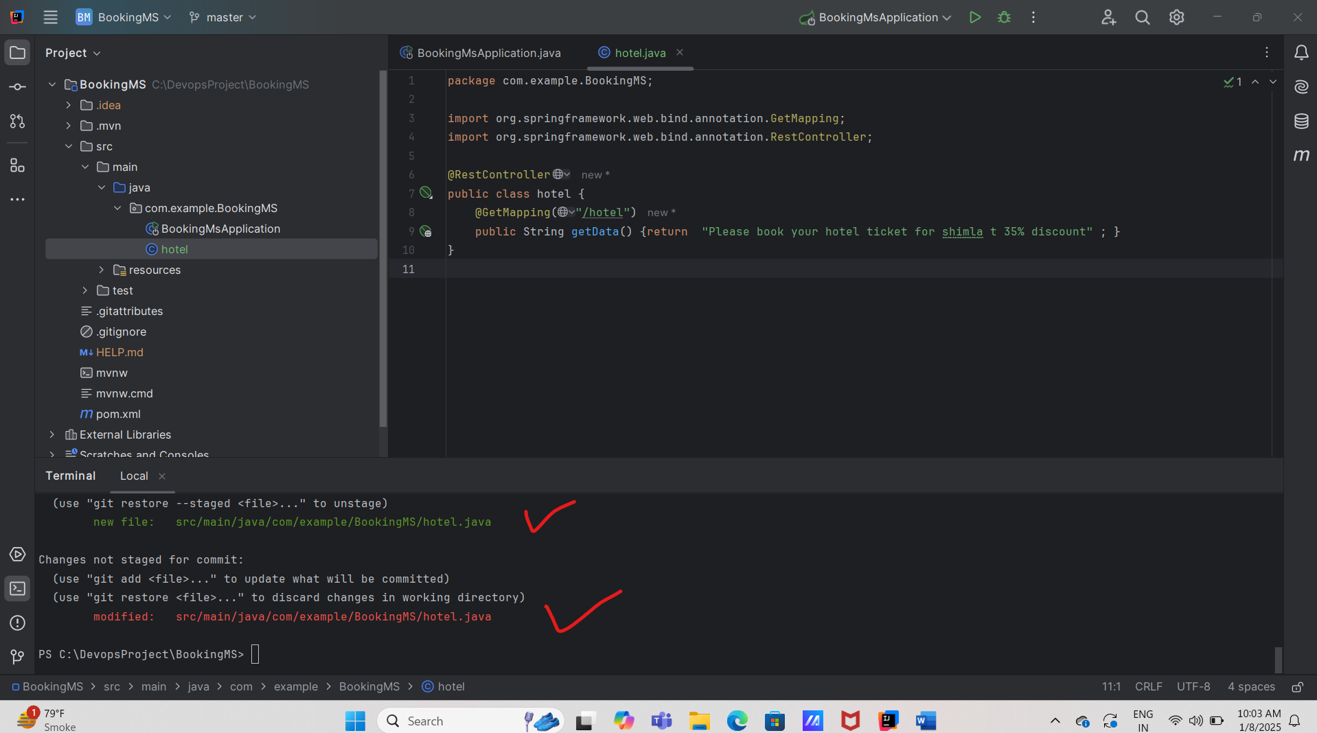

**Step 7: - Code testing using maven (compilation, packaging, code running status).**

**# mvn clean compile 🡪 to compile the newly added code**

**# mvn clean package 🡪to package newly added code**

**# mvn spring-boot:run -> to run the newly added code on local**

**# localhost:8080/hotel -> to check running application over the browser**

**# check development tools on browser, we are using get method to call/run application.**

**# Push the newly added/tested code from local to GitHub remote repo.**

**# git status**

**# git add –all**

**# git commit -m “hotel java class”**

**# git push origin master**

**# Check remote GitHub repo (is the code has been pushed successfully)**

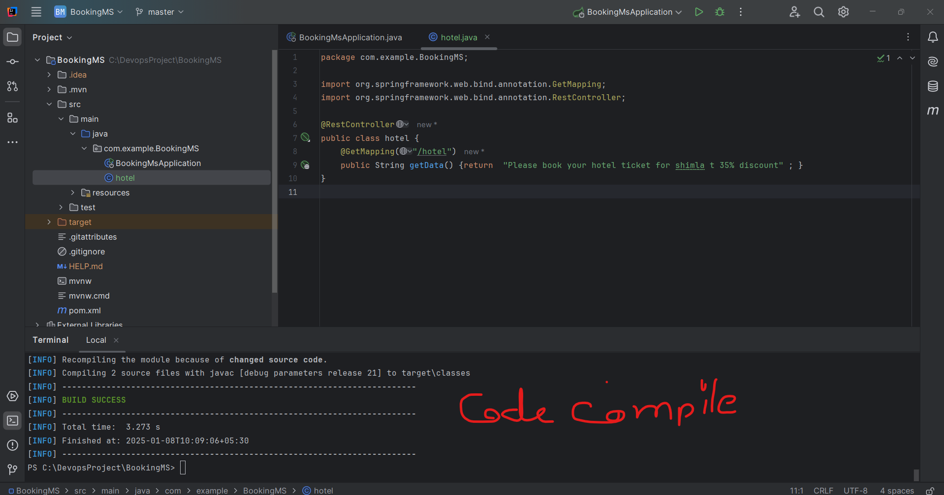

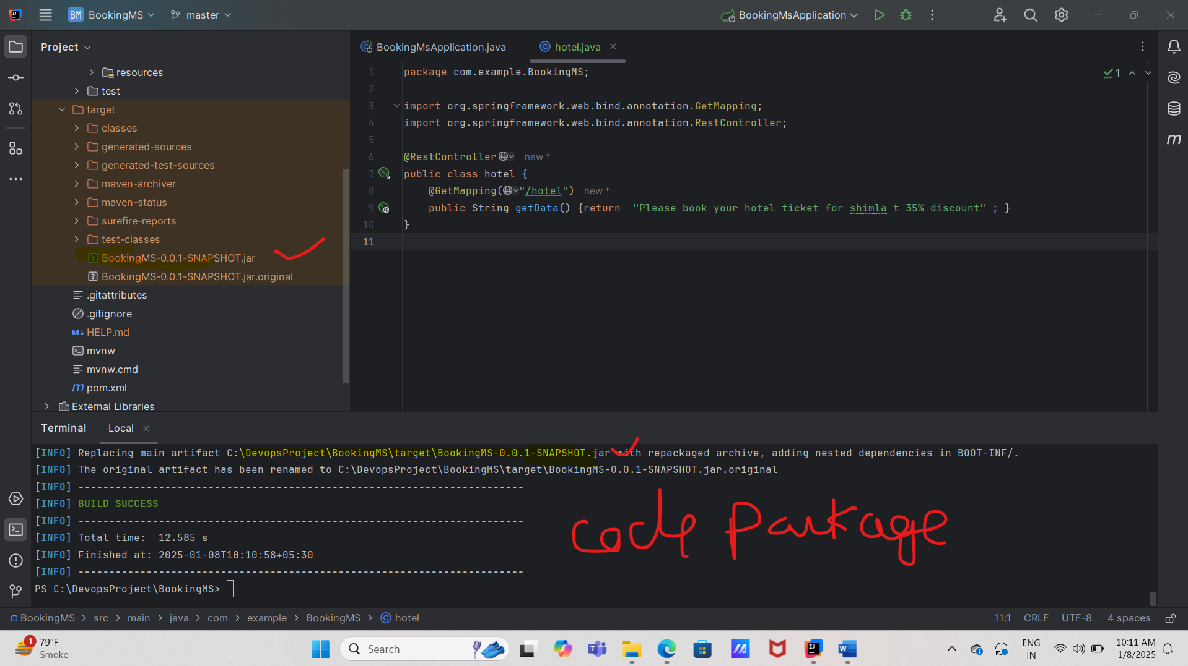

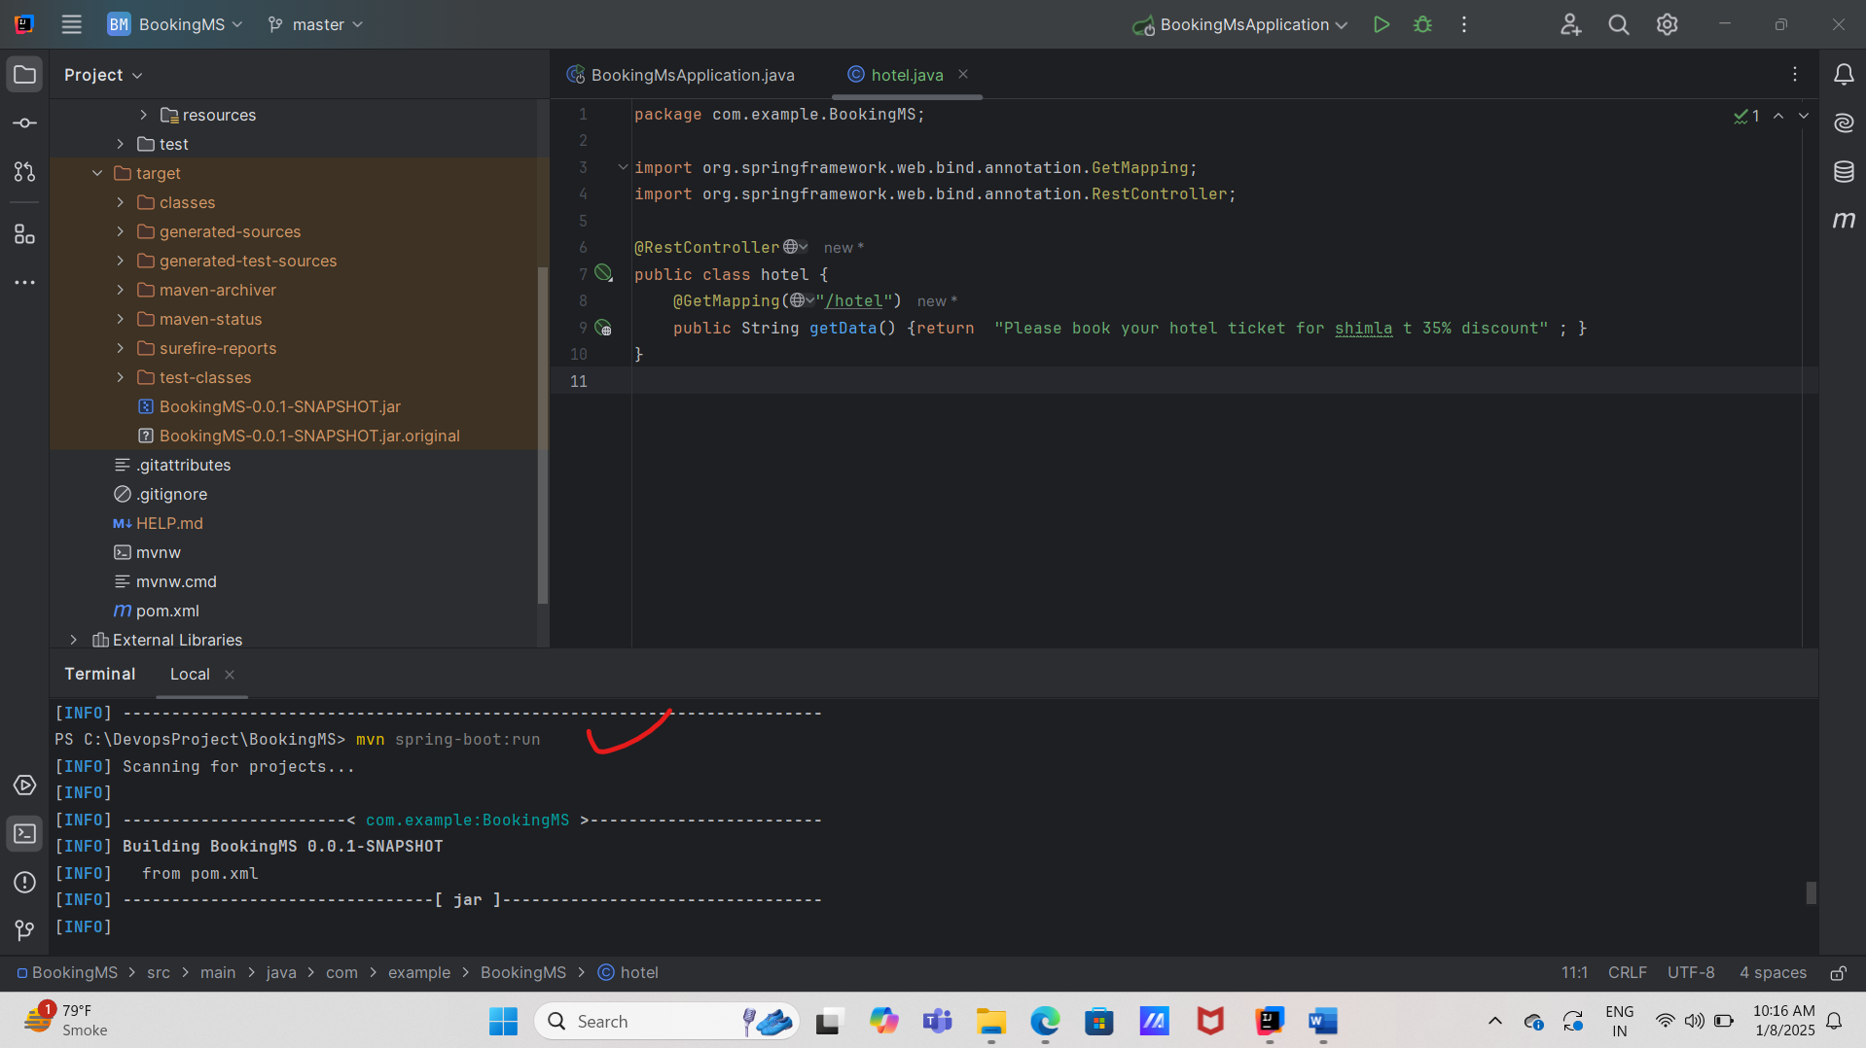

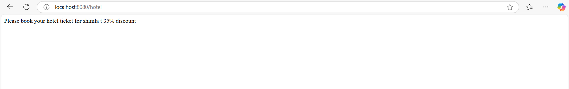

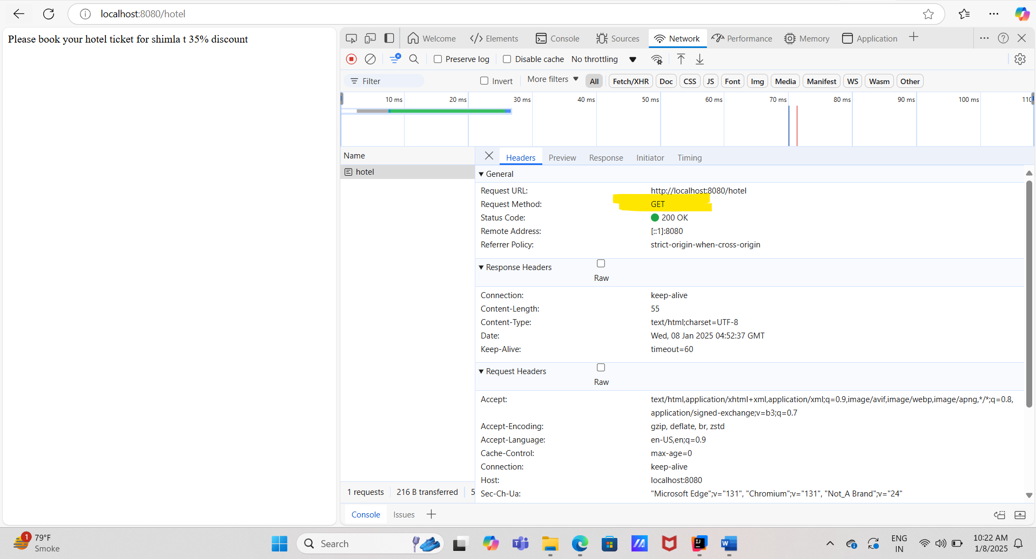

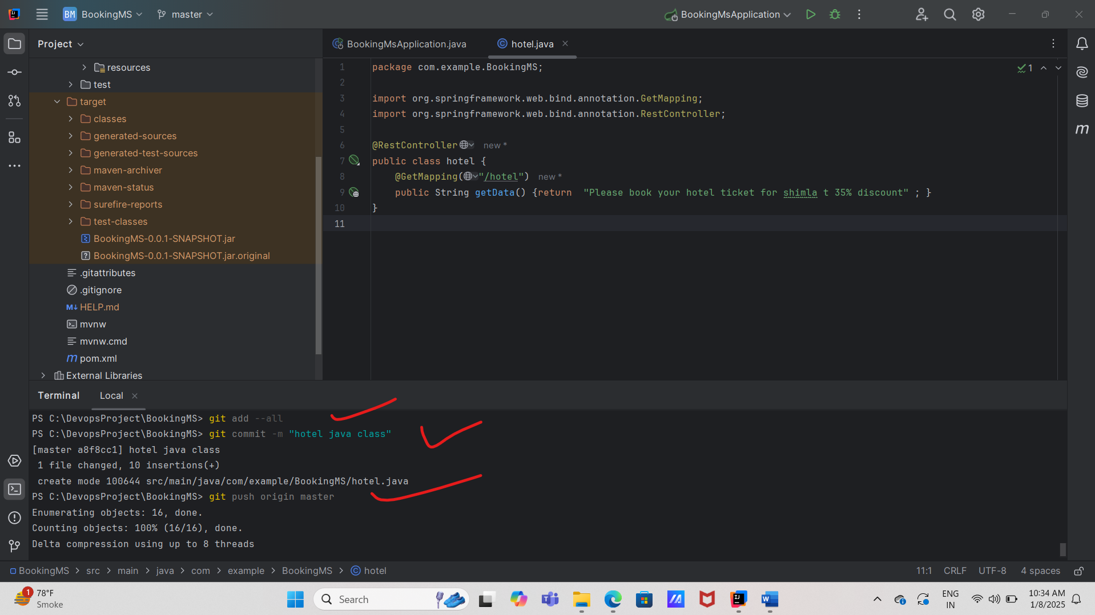

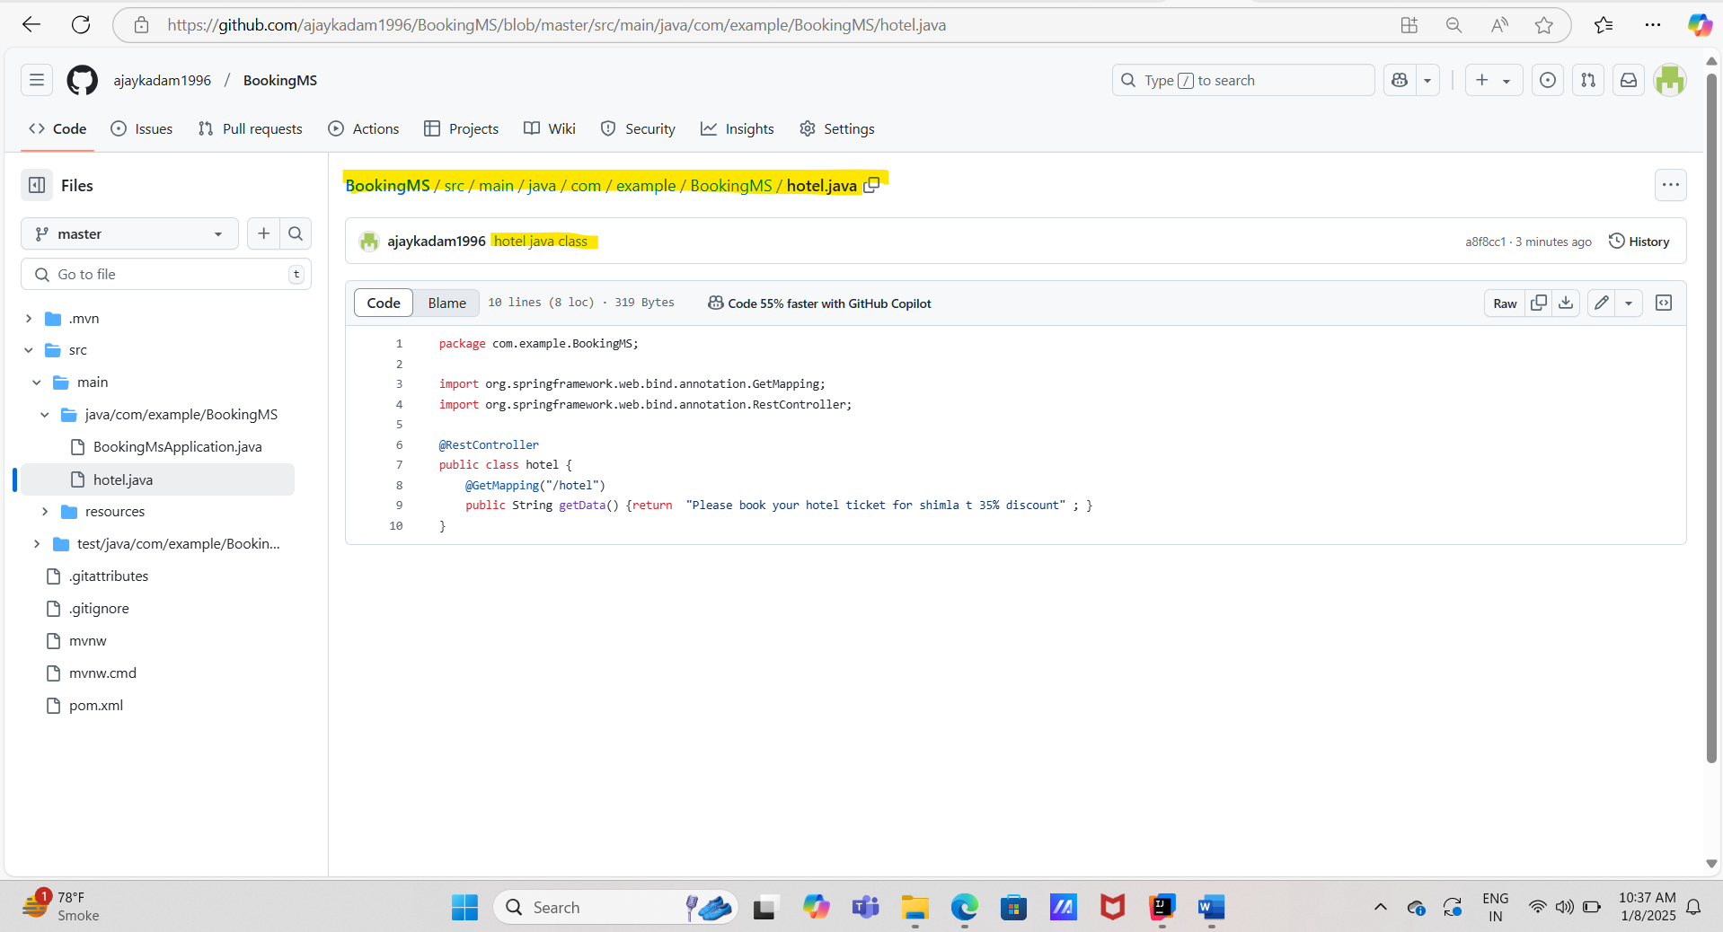

**Step 7: - Git branching (Branching strategy )**

**1). Branch creation on remote**

**# Click on the BookingMS repo/ 🡪 add new branches using switch branches/tag -> add branch name -> click on create branch from ex: create branch prod from preprod**

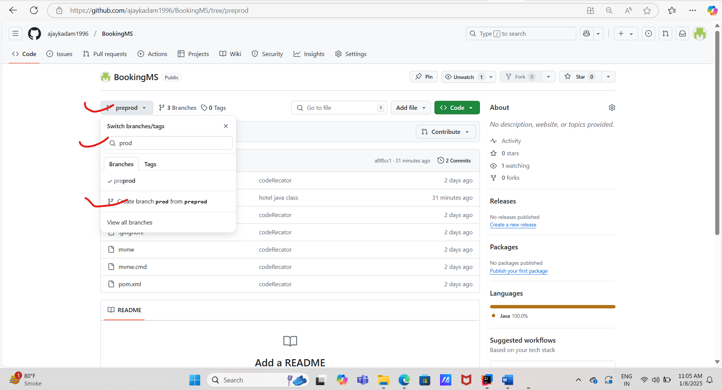

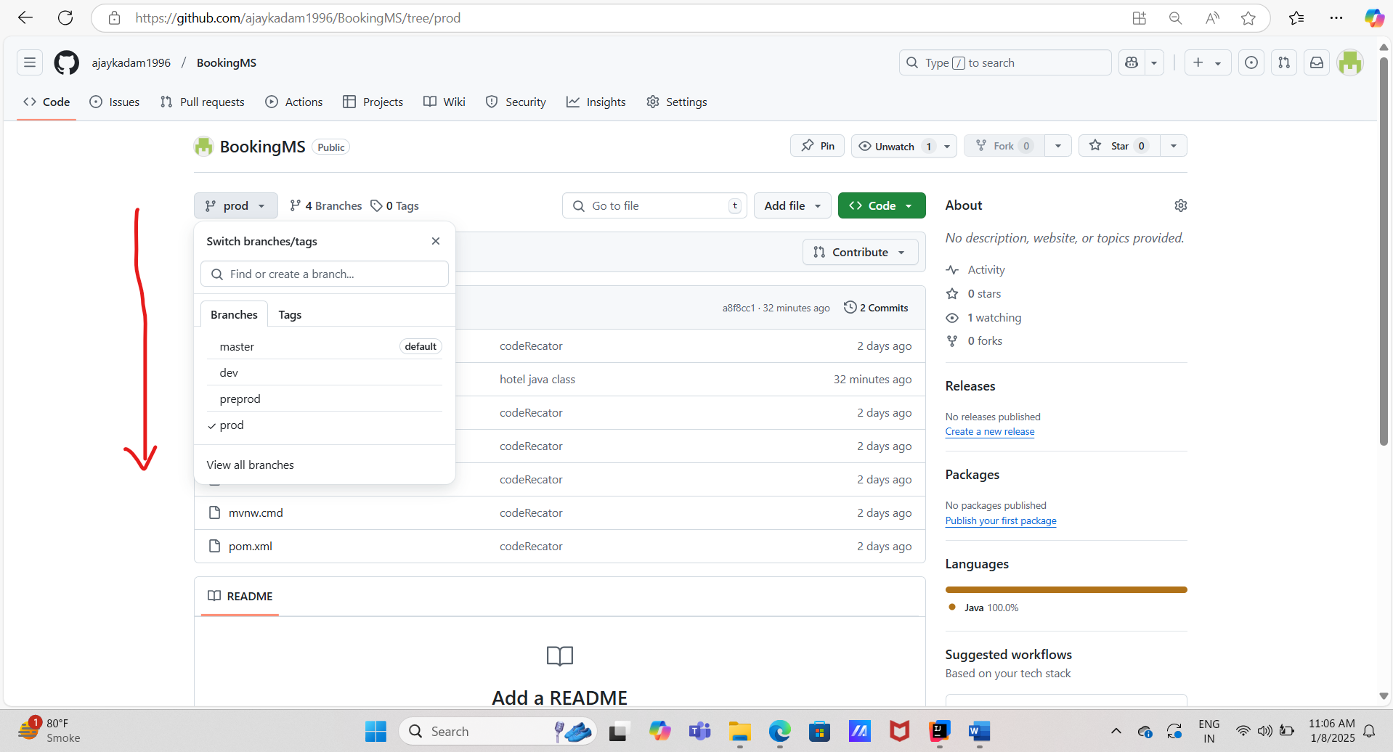

**2) Fetching the same branches from remote to local.**

**# git branch -> to check how many branches are present on the local**

**# git fetch origin dev -> Fetching dev branch from remote to local**

**# git checkout dev**

**# git branch**

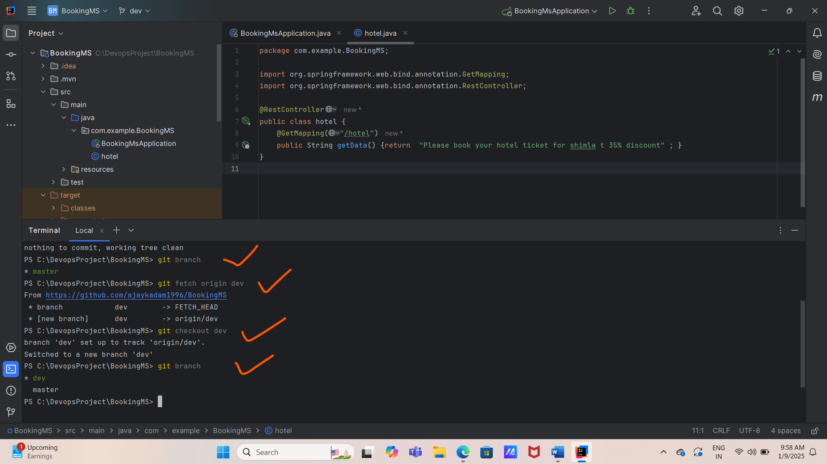

**Step 8: - Code Promotion**

**1). Creation of new java class in the existing code**

**# Add new java class ex: bus**

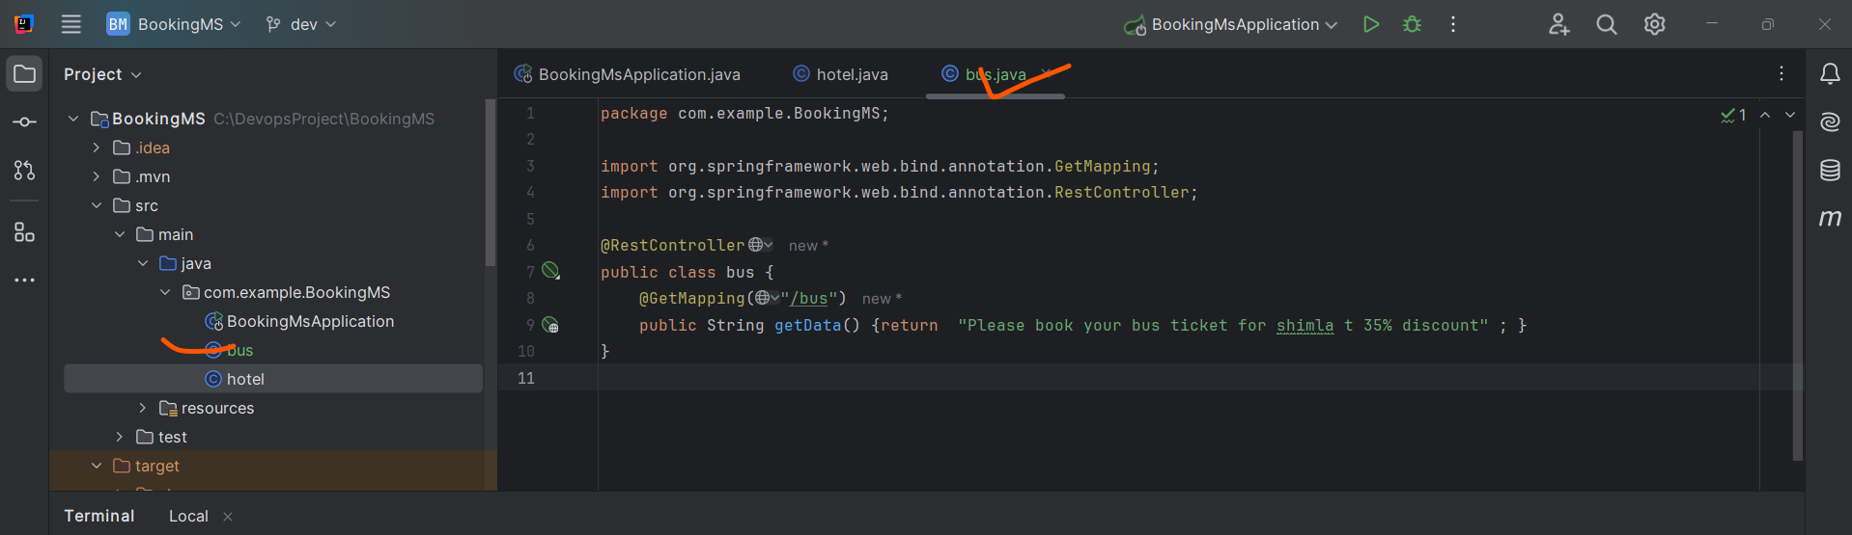

**2) Code testing using maven (newly added class)**

**# mvn clean compile**

**# mvn clean package**

**# mvn spring-boot:run**

**# Check the both applications are working fine using #localhost:8080/hotel # localhost:8080/bus**

**Make sure check previous application status before running the new application**

**#localhost:8080/hotel**

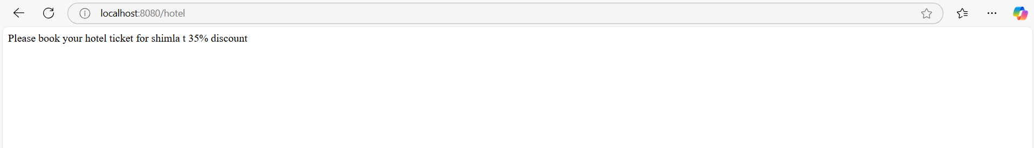

**#localhost:8080/bus**

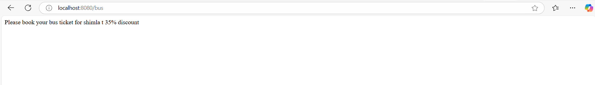

**3). Push the code (class bus) from local to remote (dev) branch**

**#git status**

**#git add –all**

**#git commit -m “new java class bus”**

**# git push origin dev**

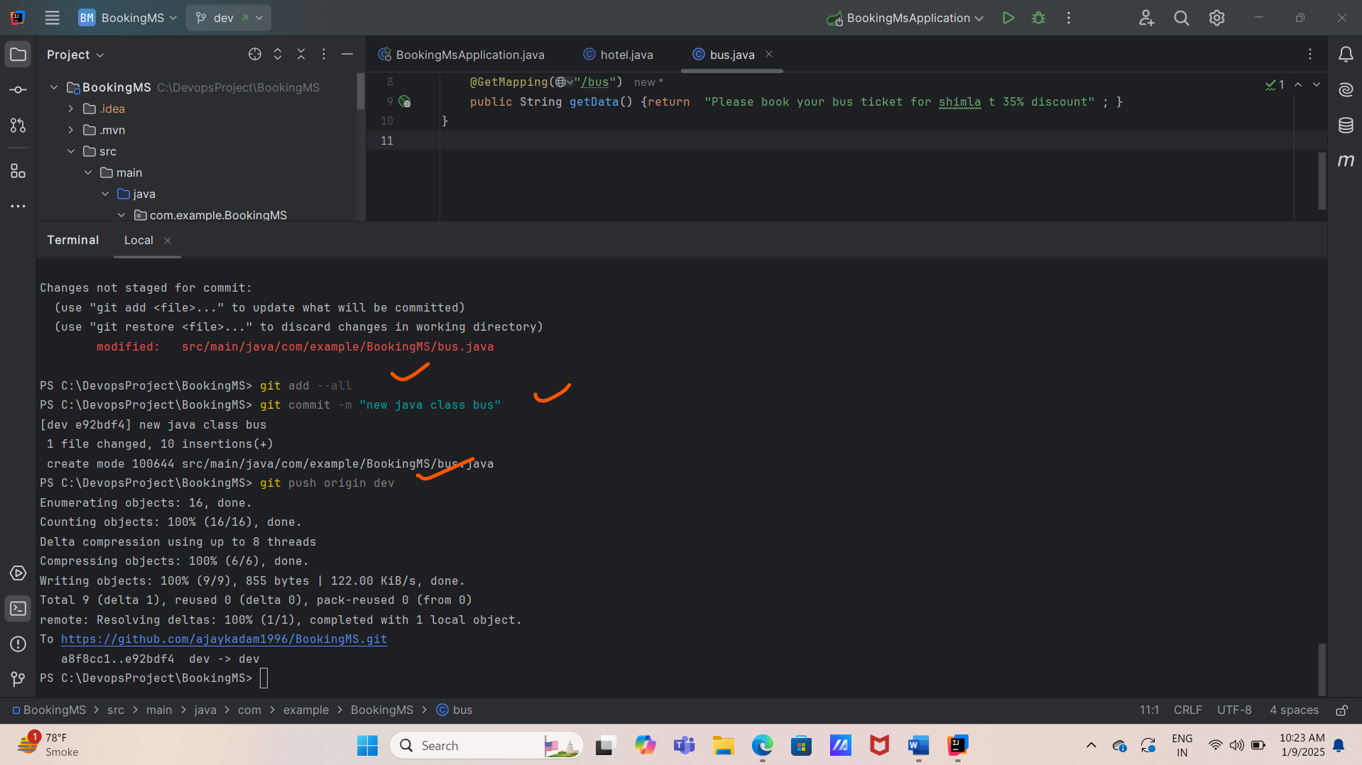

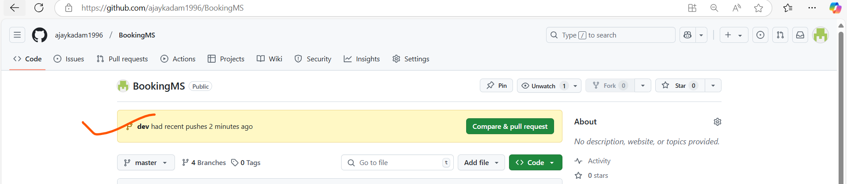

**4). Creation of Pull request (from one branch to another)**

**# Click on compare & pull request (dev to preprod)**

**# Add the description and review the code and then click on create pull request.**

**# Now we need to marge the pull request (we can assign our team members to review the pull request)**

**# Click on merge request and confirm the request.**

**#Pull operation has been done successfully from dev to preprod**



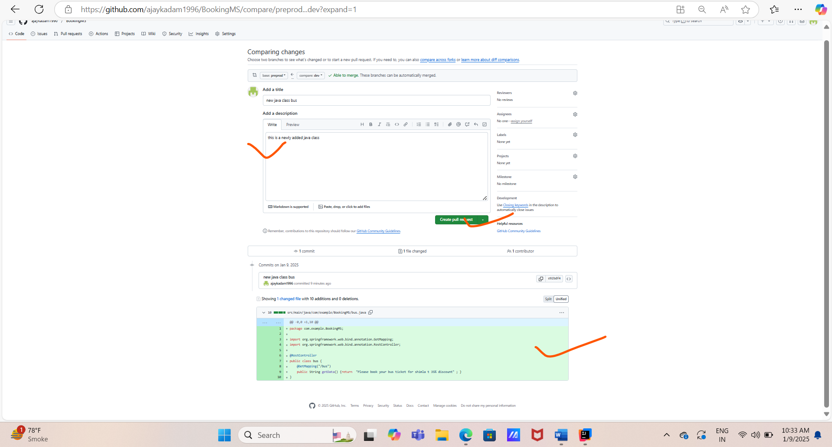

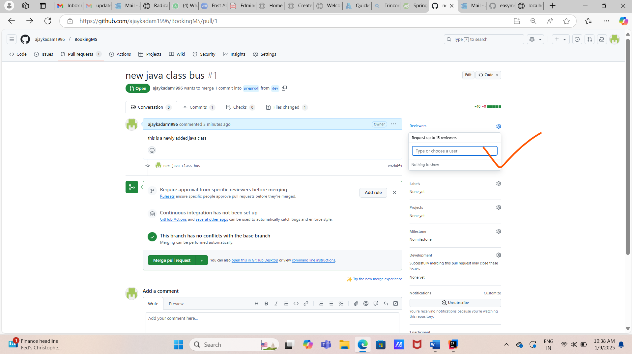

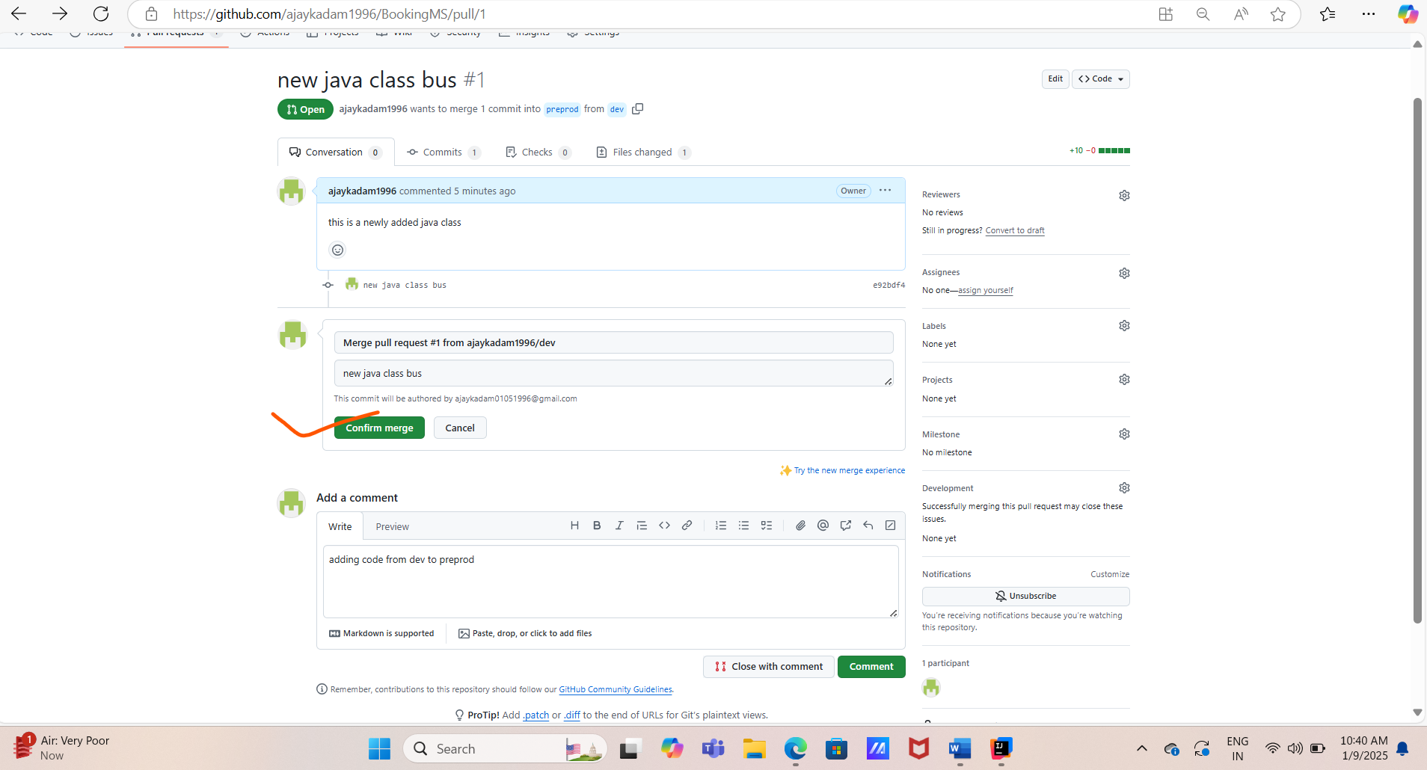

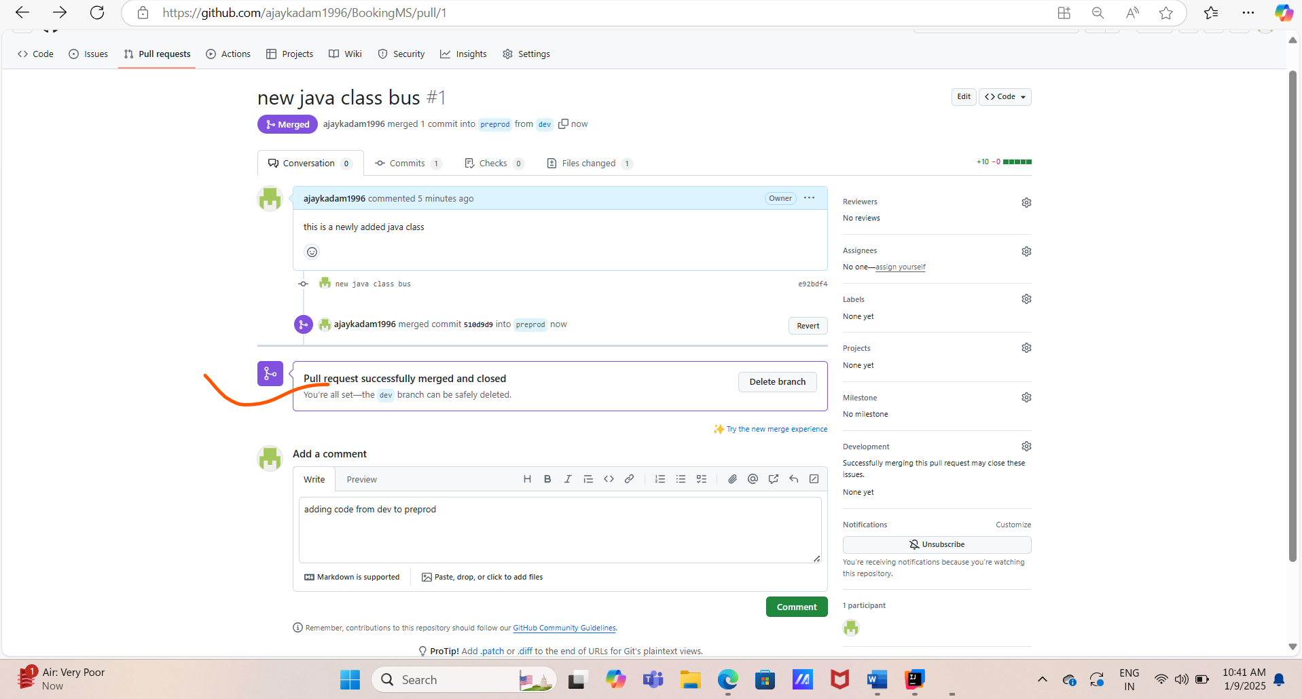

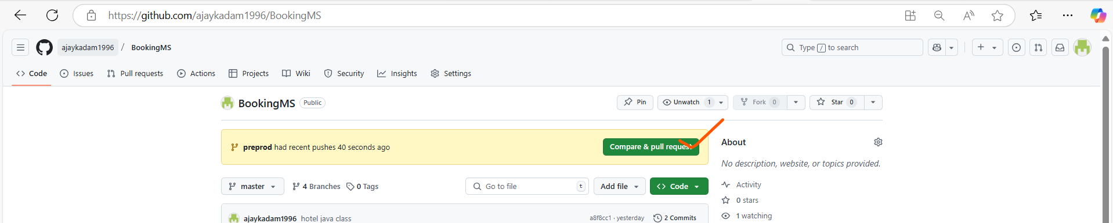

**4.1). Now we are creating pull request from preprod to prod**

**# Click on compare and pull request**

**# Select the prod branch with proper description and click on create pull request**

**# Approve the pull request and with proper comment and click on the merge pull request.**

**# Now confirm the merge request and we can see that the merge request has been completed successfully.**



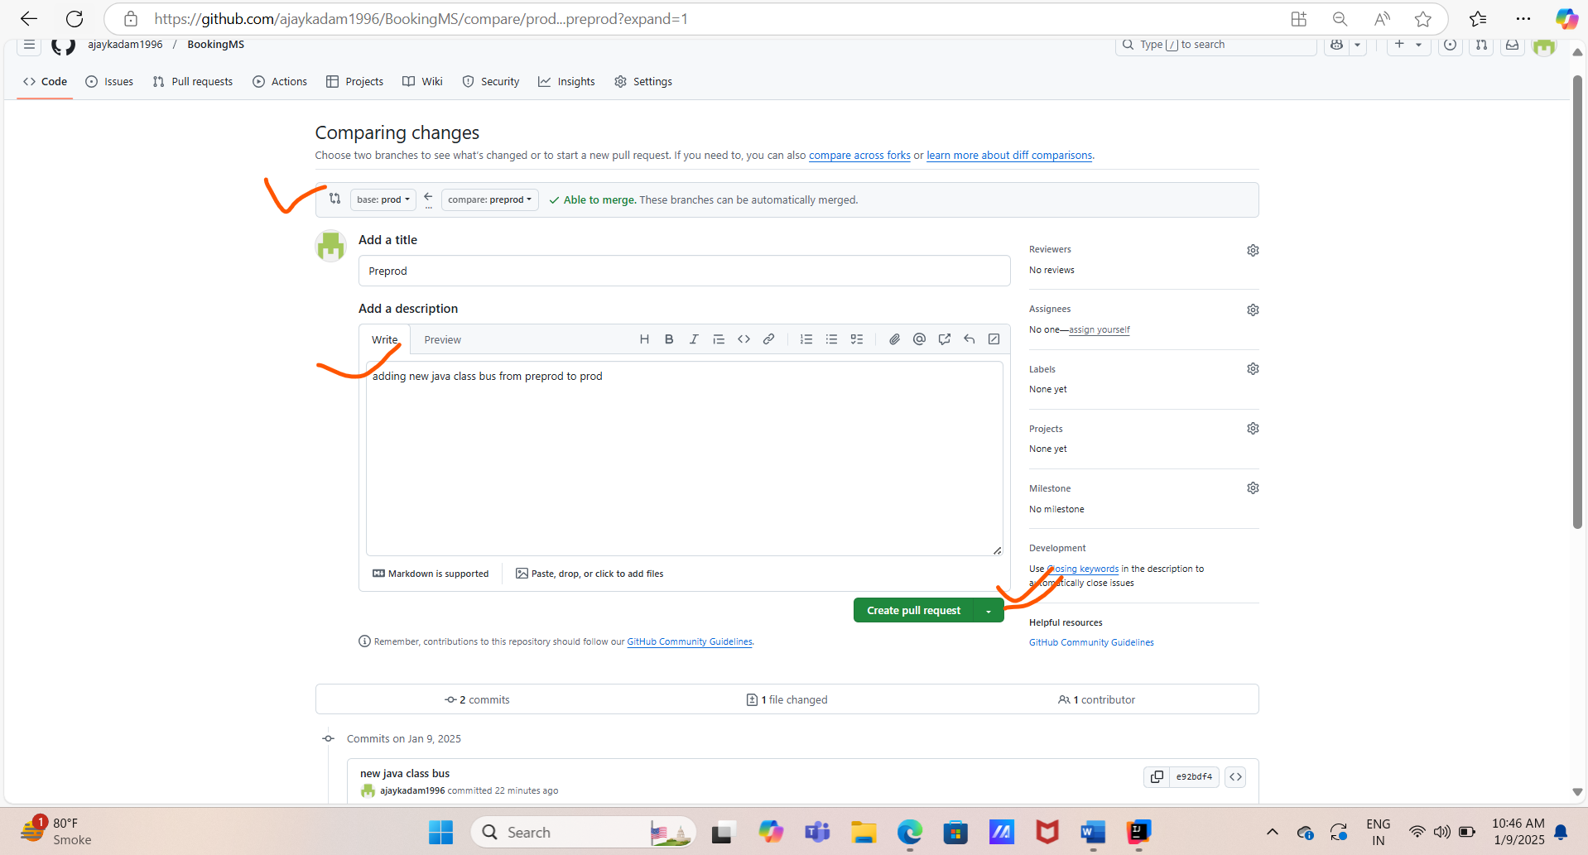

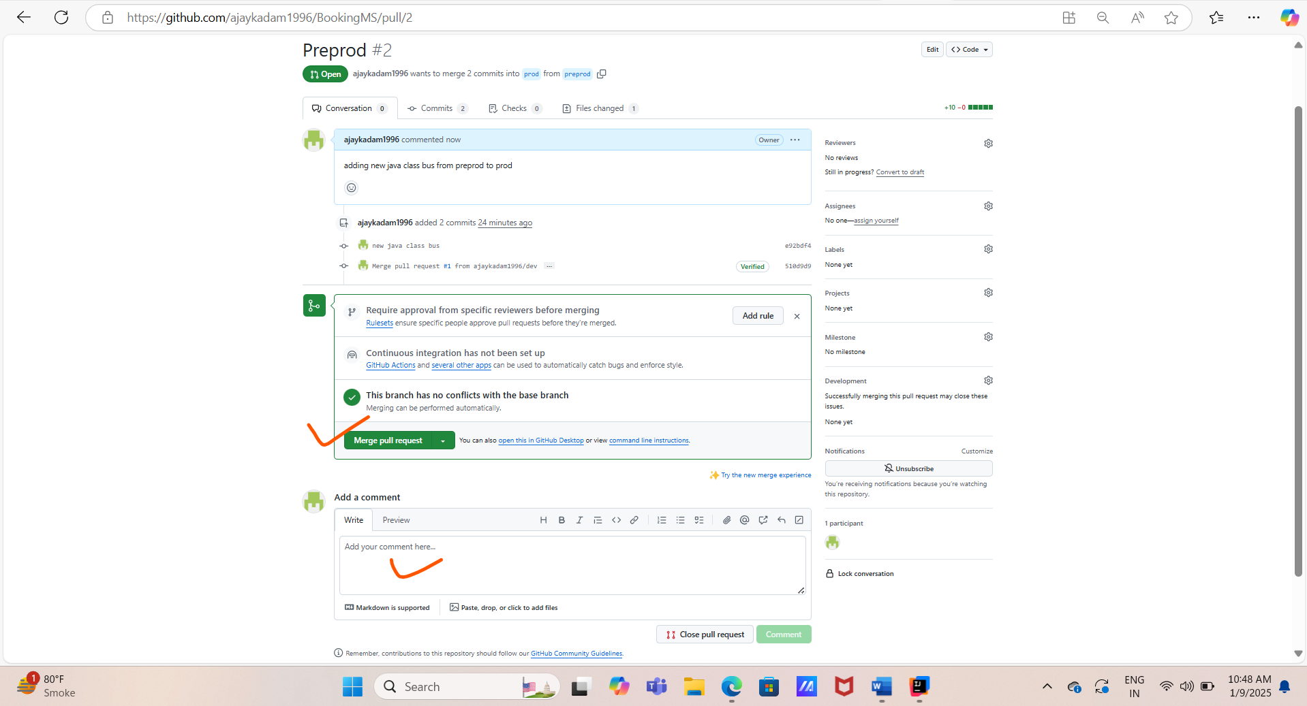

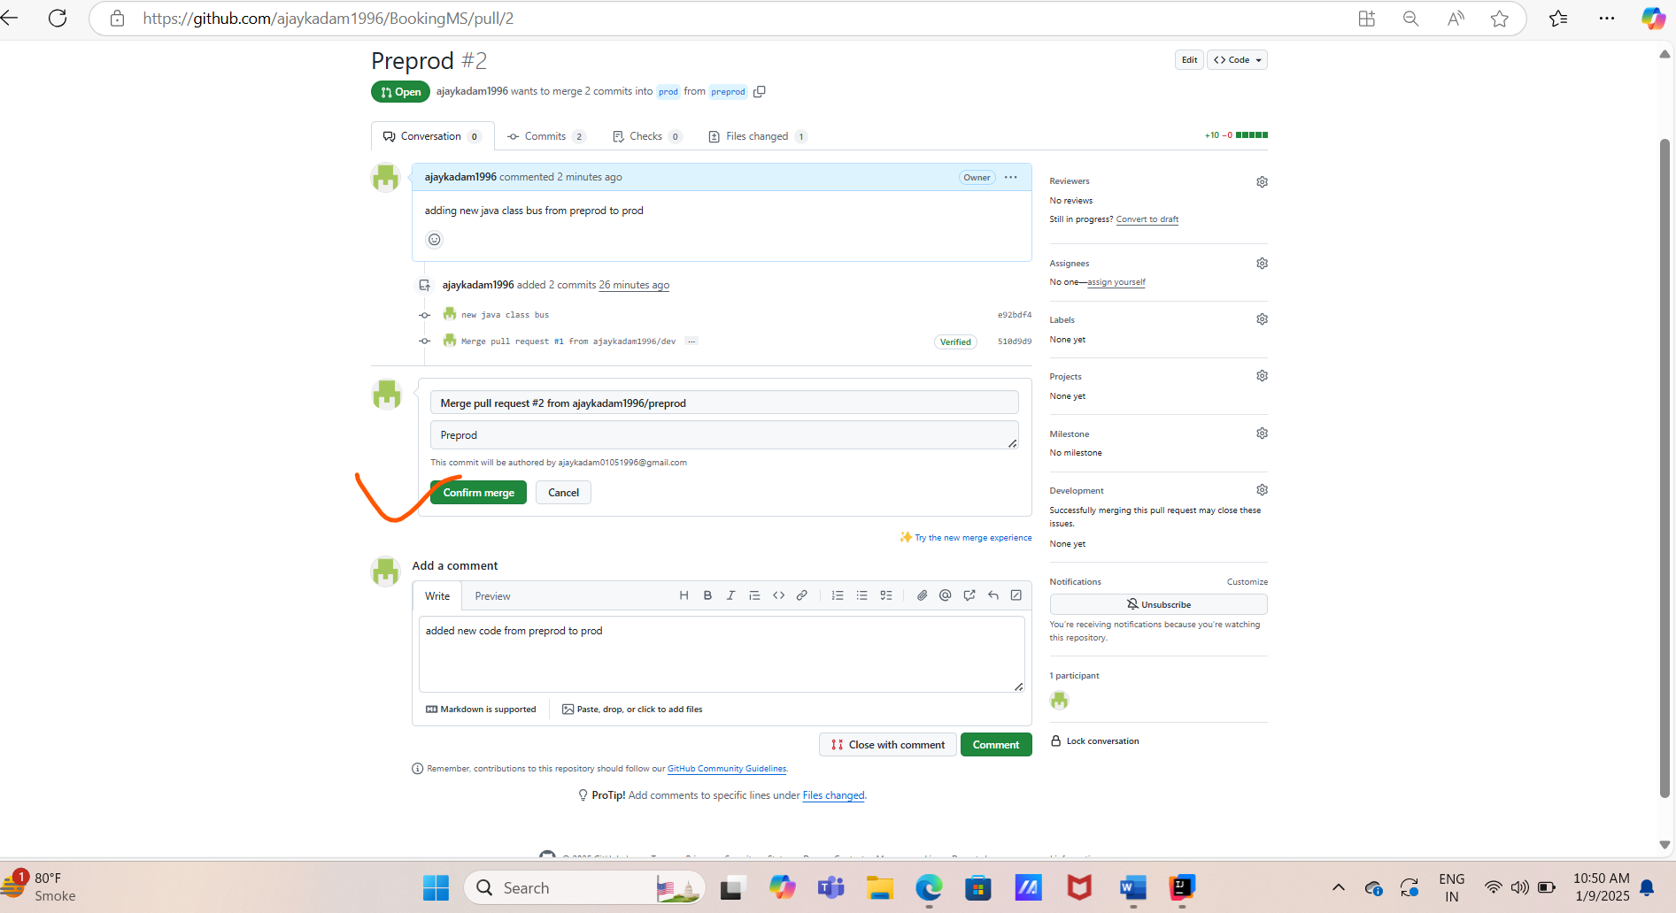

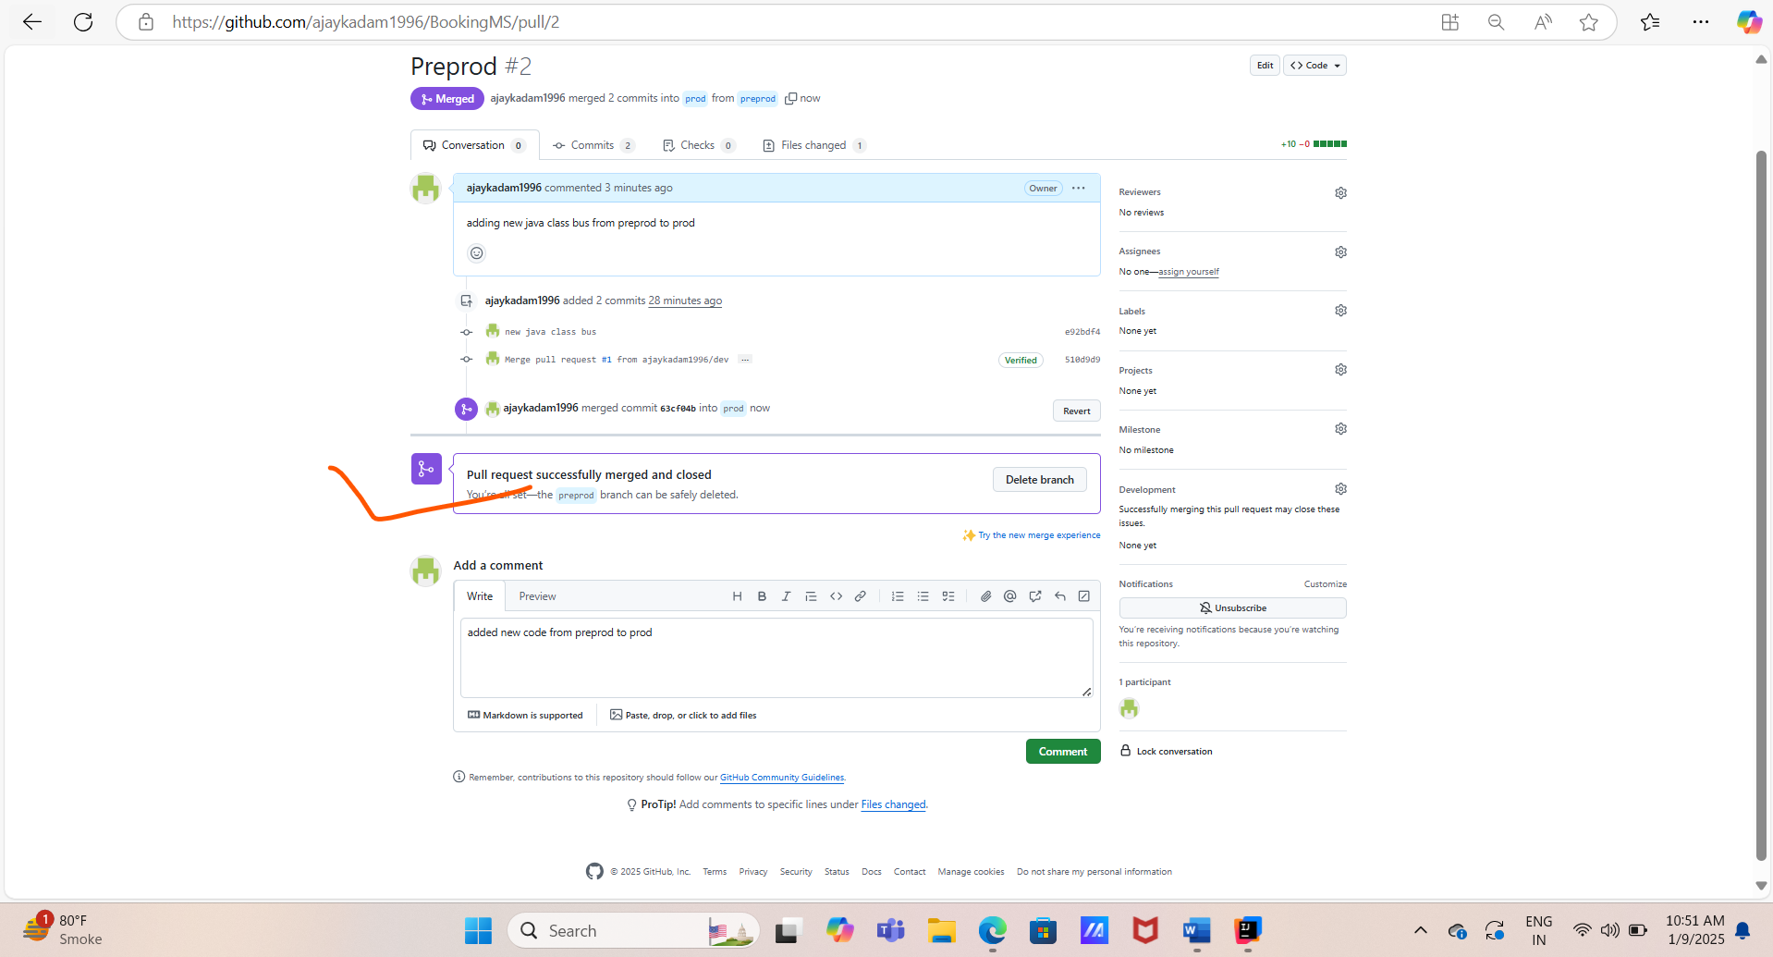

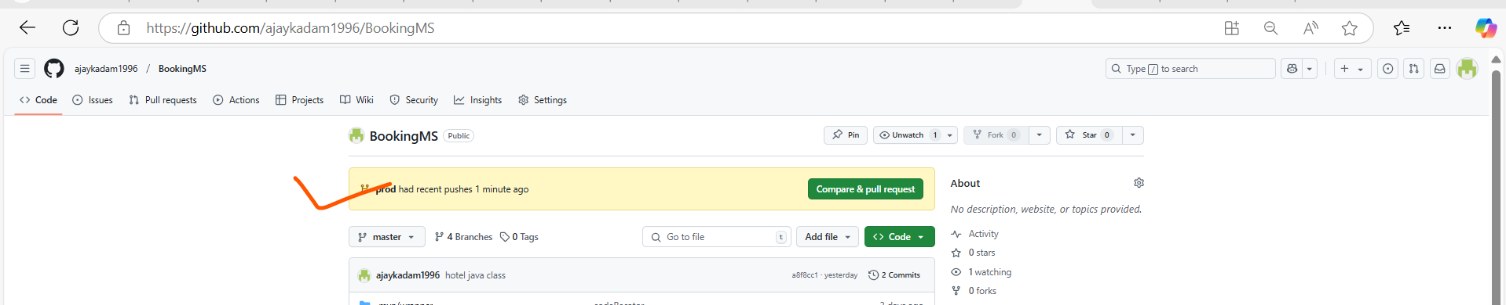

**Step 9: - Git Pull Operation and Creation of branch on local from remote branch.**

**1). Creation of branch on local**

**# git branch 🡪 to check branch status**

**# git pull origin dev 🡪 to pull from dev branch**

**# git checkout -b feature/holiday 🡪 to create new branch from remote to local ex: from dev to local**

**# Create new java class – holiday in the newly created branch 🡪 feature/holidays**

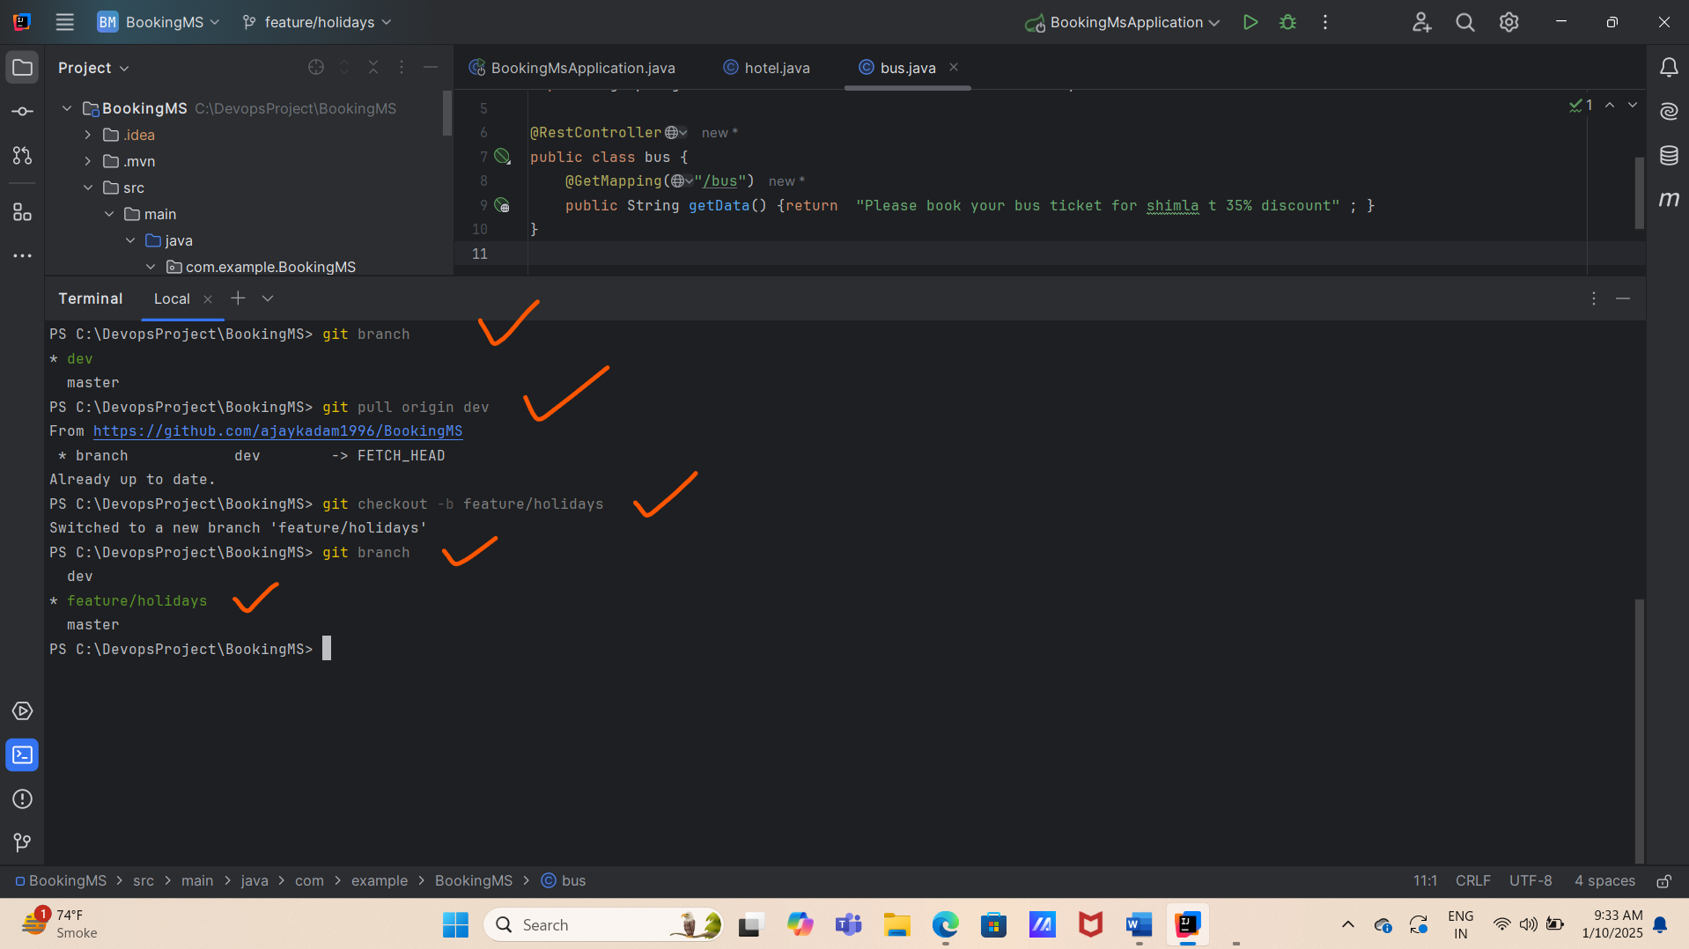

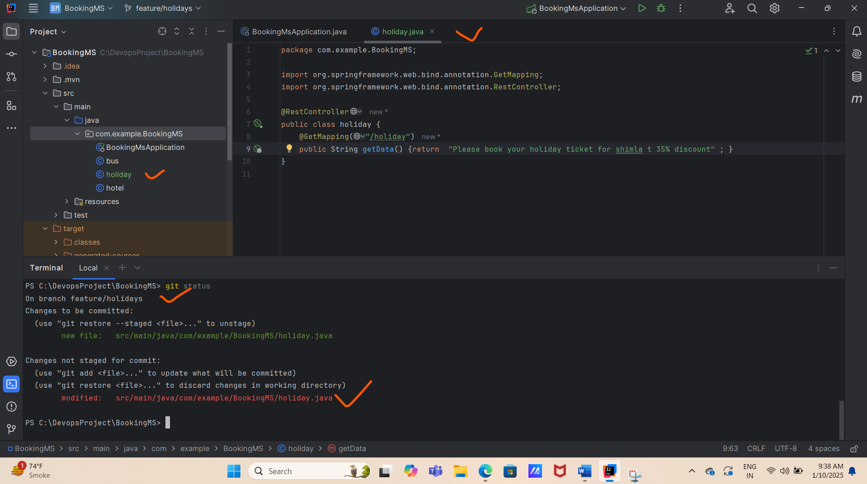

**2) Pushing the code/newly created branch from local remote /dev repo.**

**# git status**

**#git branch**

**#mvn clean compile**

**#mvn clean package**

**#mvn spring-boot:run**

**#localhost:8080/holiday**

